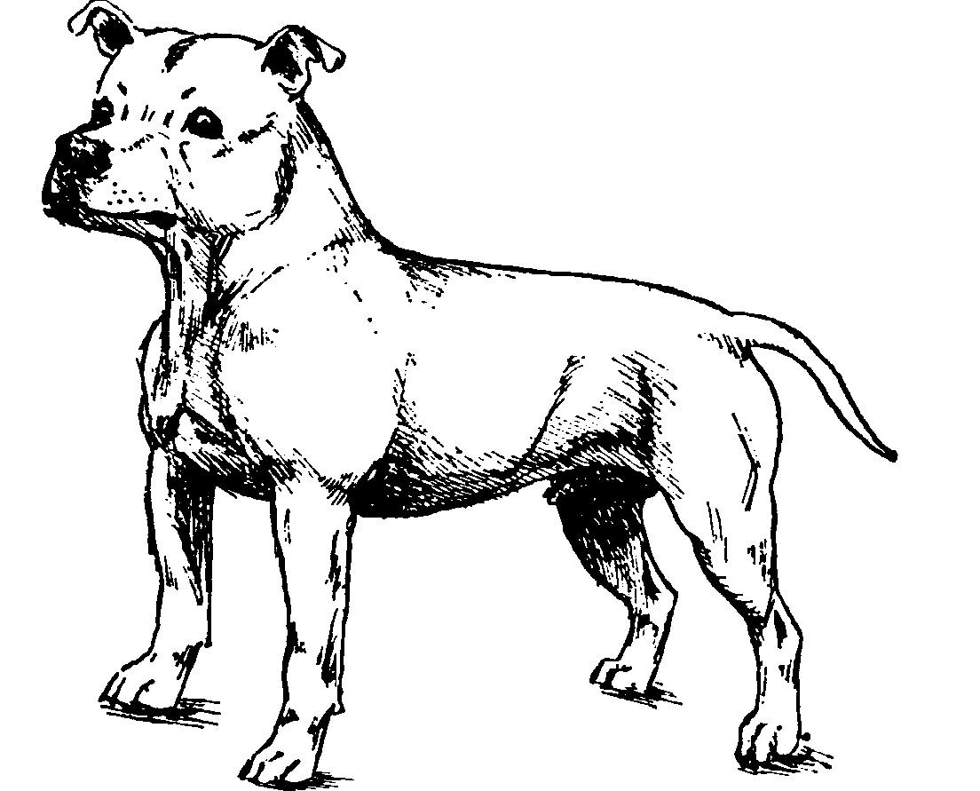
53 Ashford Avenue

Ashford
Middlesex

TW15 2BB
Tel: 01784-251020 (eve) or 020-8246-3292 (day)
e-mail: dlevy@ashford-middx.freeserve.co.uk

President Vaclav Havel
The Office of the President of the Czech Republic
Prague Castle
119 08 Prague 1
Czech Republic
3rd February, 2001
The Staffordshire Bull Terrier

Dear President Havel

I have not written to the Czech authorities before on the subject of the Staffordshire Bull Terrier, since it seems only quite recently that our breed has been linked to the idea of a list of "dangerous dogs" in your country. I am now advised that your country is considering copying the German Government's plans rather than those of the other European states.

I enclose a copy of a letter received from the French Government indicating that they agree with the British Government that this breed does not represent any particular threat to the public. I also enclose a copy of a letter from David Byrne, European Commissioner stressing that breeds cannot legitimately be banned without adequate "Scientific evidence".

You may not be aware that whilst the breed is not very common in many parts of Europe, there is an estimated population of 250,000 in the UK and the breed has never been considered a threat by our politicians or police services. Clearly, if such a numerous breed did pose any danger, this would have become evident and been addressed.

The list of SBT owners includes many well-known celebrities such as Liverpool and England footballer Michael Owen, World heavyweight boxing champion Lennox Lewis and Beatle, Ringo Starr. Many politicians own Staffords including the former deputy leader of the Labour party, Mr Roy Hattersley, a well-known supporter of European unity and I quote from an article he recently wrote for the Guardian newspaper. He states " The Hamburg senate has called for the elimination of fighting dogs and, being as ignorant as it is callous, included Staffordshire bull terriers in its list of proscribed breeds".

Unfortunately, the German Government has responded to a tragic incident in Hamburg with proposed bans on a number of breeds and in some Laender the SBT has been incorrectly included in the list. The reason given by the authorities when asked is either "another state included them" (hardly a fair basis for such discrimination) or that a book written by a German dog owner, Dieter Fleig, quotes another man named Bill Morley. In this quote, Mr Morley suggests that the dog could be a threat TO OTHER DOGS if attacked.

We have pointed out that:
- Herr Fleig has little or no experience of Staffordshire Bull Terriers
- Mr Morley (now deceased) was a show judge but he had considerably less experience than many dog judges available to give personal evidence today
- The statistics available in Germany show the number of incidents involving the Staffordshire Bull Terrier as 0 (zero!)

Many American cities and states have already found that Breed Specific legislation does not in practice provide optimum protection for the public and that better options are available based on the specific actions of owners and breeders rather than the physical characteristics of certain breeds. However, even where some breeds are proscribed, we feel it is essential to ensure that "innocent" breeds are not listed indiscriminately but only if there is overwhelming scientific evidence.

It is our submission that in reality, the main reason for the Staffordshire Bull Terrier's inclusion in some German lists is merely nomenclature confusion between this British breed and its cousin, the American Staffordshire Terrier. It would be a further injustice if this error were to be repeated in the Czech Republic.

European Commissioner David Byrne has responded to correspondence on the subject of German legislation by stating "Member States shall endeavour not to adopt measures that would exceed what is strictly necessary to cope with the actual threat caused by these dogs ". Clearly this indicates that any ban should be based solely on evidence and facts and not on confusion and muddle.

The British Home Office has responded to news from Germany by stating that they see no reason to amend the existing Dangerous Dogs Act in the UK in any way nor to extend it to include any other breeds. (See copy of letter from Mike O'Brien). Many British MEPs and MPs have written to their colleagues in Germany on behalf of their constituents to express their concern at the perverse decision to proscribe Staffordshire Bull Terriers.

The British Veterinary Association (BVA), British Small Animal Vet Association (BSAVA), National Canine Defence League (NCDL), Kennel Club (KC) and Royal Society for the Prevention of Cruelty to Animals (RSPCA) have all written to their German counterparts and the German Government expressing their view that the Staffordshire Bull Terrier does not represent any threat to the public. The European veterinary federation (FVE) has published a briefing paper highly critical of breed specific legislation.

In summary, the Staffordshire Bull Terrier is a breed of dog that:
- Exists in the UK in large numbers without any particular problem
- Is owned and respected by well known celebrities and politicians
- Is not significantly identified in any statistical evidence
- Is not considered a threat by any of the major UK animal related organisations

I believe that the German Government must soon re-consider the case of the Staffordshire Bull Terrier in light of the huge mass of evidence from animal organisations, authorities, the European Commission and the general public.

I urge you to consider these facts and make the only logical decision, based on these demonstrable facts and exclude our breed from any list of dangerous animals thereby allowing the Czech Republic's dog owners the same freedoms and enjoyment available to their European compatriots.

Yours sincerely

David B Levy
SBT KC Liaison Officer

Cc Prof. Ing. Vaclav Klaus, CSc - Chairman of parliament
Ing. Milos Zeman - Prime Minister

