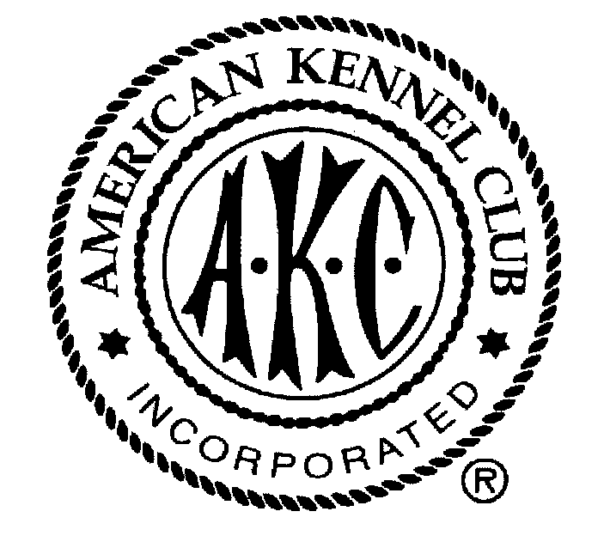Opposing Breed-Specific Legislation
Strategies for dealing with lawmakers, the public, and the media

Understand The Background Of The Issue
Breed-specific dangerous dog legislation is usually proposed in response to a specific attack by a dangerous animal or wave of irresponsible dog ownership in a community. Proponents of such legislation are trying to find a way to protect members of their community, and have latched onto the idea of breed-specific legislation as a quick and easy solution to animal control problems. The first step towards defeating a proposed breed-specific law is finding out as much information as possible about the proposal. This includes:
Why was the legislation introduced? Was a specific incident the motivation? Is similar legislation being proposed in the area?
Who are the sponsors and key supporters? Who drafted this legislation? Who in the city or county government (and in the local community) is actively supporting the idea?
What does the proposal say? Contact your municipal clerk’s office to obtain a copy of the proposed law.
When will the proposal be voted on? Contact the municipal clerk for the time, date, and place of meeting where this proposal will be discussed. Inquire if there will be opportunities for members of the public to speak and if written testimony will be accepted. Inquire if the idea has to be reviewed by any committee before it is considered by the entire city or county council.
What animal control laws does your community already have in place? It is possible that your community already has laws on the books to regulate dangerous dogs. Instead of a new law, better enforcement of existing laws could be the solution.
is there a state pre-emptive law? Your state may also have a law that prohibits local communities from passing breed specific legislation. The local government may not be aware of this state law. Ascertain whether the state law will cover the local issue.

Getting Organized
Once you have all the facts, it is time to get organized. These key steps can help you effectively express the views of the purebred dog fancy.
Contact the AKC When you hear about legislation that could impact purebred dog owners, call the AKC’s legislative department (919-233-3720) or email doglaw@akc.org. The AKC can provide advice, materials, sample legislation, and contact information to area fanciers, and may also be able to send letters to support the fancy’s position.
Organizing a group of supporters When working towards a legislative goal, numbers count. Gather together as many individuals as possible who are committed to defeating a breed-specific initiative. Fellow dog club members, local veterinarians, friends and neighbors are all potential supporters. A committed group is needed to attend and testify at public meetings, and to write, call, and meet with lawmakers to express the fancy’s position.
Educating supporters You and your supporters need to know as much information as you can about any breed-specific proposal, the current law, and the arguments for and against the proposal.
Planning a strategy Once you have a committed group of supporters, develop a strategy reflective of the time and resources available. Some questions you should consider include:
- Has the fancy previously established any relationships with lawmakers or the media that could be helpful?
- Does the fancy have any dogs of the targeted breeds which have had a beneficial impact on the local community? Beneficial impact could include therapy dogs, local “heroes,” or mascots. These dogs can be great ambassadors for the targeted breeds. Do you know any influential people with these targeted breeds?
- Is there enough time to meet privately with lawmakers to discuss the issue and build influence?
- Is there time to alert the media through press releases, letters to the editor, or by giving interviews?
- Are there other means available to make the public aware of the disadvantages of breed-specific legislation?
- How can the fancy best encourage supporters to attend public meetings, call lawmakers, and write personal letters expressing their opinions on this issue?
- Who will give public testimony and talk to the media about breed-specific laws? What will they say?
Developing a unified message It is very important that supporters fully understand the arguments against breed-specific legislation. Planning what you will say in response to a breed-specific proposal will help the fancy sound organized and professional, and delivering unified themes will make a greater impact on lawmakers, the public and members of the media.
-OVER-

Points To Address Regarding Breed-Specific Laws

Why the purebred dog fancy is concerned about this issue
No group could be more concerned about the problems inadequate animal control and dangerous animals can cause a community than the purebred dog fancy. The dog fancy’s goal is non-discriminatory, fair, effective and enforceable legislation that addresses the pertinent animal issues in the community.

Breed-specific laws are not the best way to protect communities
Breed-specific laws are only a stop-gap measure. Instead of holding all dog owners accountable for their behavior, breed-specific laws only place restrictions on the owners of certain types of dogs. An owner intent on using his or her dogs for malicious purposes, such as dog fighting, will simply be able to switch to another type of dog and continue to jeopardize public safety. The list of regulated breeds or types could grow every year without ever addressing responsible dog ownership. Deeds, not breeds, should be addressed in the ordinance.

Breed-specific laws are hard to enforce. Regulations that target specific breeds force law enforcement officials to focus their valuable time on breed identification. This task requires expert knowledge of the individual breeds and is compounded when the law includes mixed breeds. It is very difficult for public officials to enforce such provisions fairly and effectively.

Breed-specific laws are unfair to responsible owners
Many owners of the targeted breeds are extremely responsible and loving towards their pets. The breed-specific laws may prevent responsible owners from freely interacting with, showing, breeding or performing pet therapy with their dogs. In addition, this type of legislation may cause financial hardship to responsible owners.

Breed-specific laws could increase costs for community
Shelter costs for the community could rise as citizens abandon household pets of the targeted breeds at the shelter because of inability to comply with the breed specific laws. In addition, adoptable dogs of the targeted breeds would be euthanized at the shelter.

Breed-specific laws may not withstand legal challenges
Some communities have had their breed specific laws overturned upon constitutional challenges. Because proper identification of what dogs would be included is difficult or impossible, the law may be deemed as unconstitutionally vague. It may also be found to involve the taking of property without due process.

A better solution is available
Strongly enforced animal control laws (such as leash laws), generic guidelines on dealing with dangerous dogs and increased public education efforts to promote responsible dog ownership are all better ways to protect communities from dangerous animals. Increasing public education efforts will help attack the root cause of the problem--irresponsible dog owners.

Uniformly enforced generic laws will force all owners, regardless of what breed of dog they own, to be responsible animal owners. They will also prevent irresponsible owners from simply turning to a different breed. Generic laws will allow public safety officers to focus all of their time on holding pet owners accountable for their actions and the behavior of their animals. A breed-specific law would require officers to divide their time between protecting the public and performing questionable breed-identification.

The purebred dog fancy and the AKC are valuable resources
The purebred dog fancy is extremely interested in developing fair and effective animal control laws and dangerous dog regulations, as well as bolstering public education efforts to promote responsible dog ownership. To help achieve these goals, the fancy will assist the community by serving on or starting animal control advisory boards to monitor problems and help develop reasonable solutions, and volunteering time and resources to help start or improve public education campaigns to teach responsible dog ownership.

The AKC’s Canine Legislation and Public Education departments can also assist communities. The Canine Legislation department will provide sample legislation and help to develop or improve animal control laws. The Public Education department will give communities free materials and assistance in conducting responsible dog ownership campaigns.

